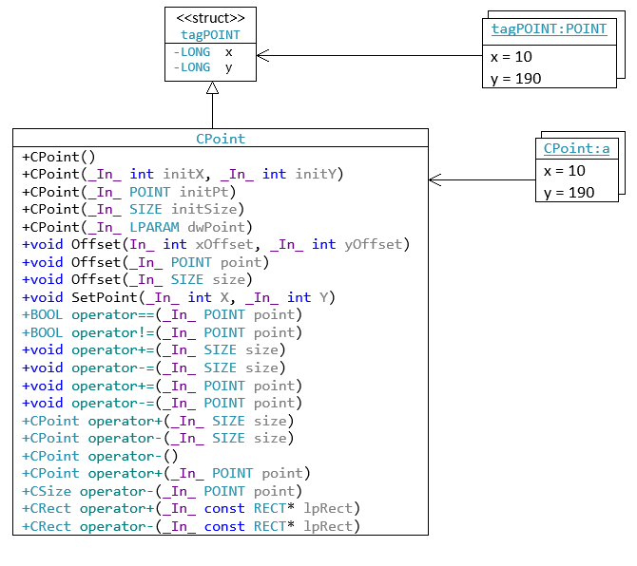

MAIN

|  |
| --- |
| int main()  {  CPoint a(10, 190);  } |